South East London Primary Care Pack

Southwark and Lambeth

About this resource pack:
This resource pack has been developed to support GP practices and wider primary care teams across South East London in accessing key pathology information and navigating relevant processes and pathways.
It brings together useful guidance, key contacts, service information and supporting resources in one place, making it easier for teams to find the information they need when working with Synnovis and supporting patient care.
Designed as a working resource, the pack will continue to be updated alongside services and local priorities, helping to ensure the information remains current, relevant and useful for primary care.

Contents:
Pathology contact details | 4
Courier collection guidance | 5-6
GP training closure poster template | 7
Swiftqueue patient flow chart and phlebotomy hubs | 8-9
Phlebotomy dos and don’ts | 10
Blood collection order of draw chart | 11
Primary Care pathology structure & organisation | 12-18
Infection Sciences test consumables guide | 19

Synnovis Customer Support
Contact customerservices@synnovis.co.uk or 0204 513 7300 for pathology queries including results, add-ons, logistics and consumables, sample/test information and clinical advice.
The team is available Monday to Friday, 08:00 to 18:00. More information can be found at Customer Service - SYNLAB UK & Ireland
Please include as much information as possible, including relevant patient details, to allow for early investigation.

Pathology IT Issues
Contact tquest@synnovis.uk for any pathology-related IT queries, including tQuest user set up, enquiries, issues, result interchange errors & unmatched/unknown GP results. No Patient Identifiable Details please.

Primary Care Borough Team
Contact Primarycareteam@synnovis.co.uk for engagement, support and further escalation.

Synnovis Communications
Synnovis updates, clinical alerts and newsletters will be sent to you from a dedicated email address, ServiceUpdate@email.synnovis.co.uk.

Logistics Escalation Pathway
To report a missed or late collection, please contact the GSG Synnovis Helpdesk on 0203 840 3610 who will assess the courier’s status and arrange for an immediate resolution.
Live courier collection schedule: Collection times - SYNLAB UK & Ireland

Website Information
Including logistics, reference ranges, critical telephoning limits and offline request forms
Primary Care Resources - SYNLAB UK & Ireland

Collection Times
Your site’s collection time can be viewed at: https://sel.synlab.co.uk/logistics/collection-times/
Please note:
- Collection times indicate the expected arrival window, with an acceptable ±15-minute variation.
- Collection times may change periodically as per the date indicated on the website, so please contact the team if you require the latest schedule

Synnovis Transport Bags
All routine samples must be placed in Synnovis orange transport bags, sealed securely before collection. Order transport bags via the Synnovis Consumables Portal: https://synnovisportal.co.uk/
To request a portal account, email: customerservices@synnovis.co.uk with: Site’s generic email, Full site address (including floor, if applicable), Postcode and Direct contact number
Sample Storage Before Collection
Store most samples at ambient room temperature before collection.
Do not refrigerate blood samples, as cold temperatures may affect results.
Microbiology urines should be collected in boric acid containers for stability.
Biochemistry urines and stool samples may be refrigerated if stored overnight.
If samples must be stored longer than expected, contact Synnovis Customer Services to review collection arrangements.

Preparing Samples for Collection (Collection Etiquette)
Sites must ensure:
All samples are packaged in Synnovis Transport Bags, sealed securely. Couriers cannot package or seal samples; this must be done before they arrive.
Couriers may arrive 15 minutes before or after the scheduled time. Samples must be sealed and in the designated area before the earliest time in that window or handed directly to the courier. Unprepared samples risk being left behind.
Couriers need quick access to the site, collection point, and any secure areas and any specific arrangements must be communicated to Synnovis.
Missed or delayed collections are reported within 30 minutes through the escalation pathway. Any changes to access, collection points, or out-of-hours arrangements are communicated promptly.

Escalation Pathway (Missed or Late Collections)
If your collection is missed or delayed, follow the two-stage pathway below:
Stage 1 – Escalate within 30 minutes
Contact GSG via the details on your Primary Care Courier Escalation sheet.
GSG will provide operational updates such as an ETA or arranging an urgent collection.
Stage 2 – For formal investigation
Do not raise formal complaints with GSG. Instead, contact Synnovis Customer Services & Logistics:
- Phone: 0204 513 7300
- Email: customerservices@synnovis.co.uk
Synnovis will review the concern with GSG, identify the root cause, and provide corrective or preventative actions.

Delayed Samples Identification
If you identify that blood samples were not collected for your site, report this immediately via the escalation pathway and ensure you complete the following actions:
- Record bag number(s) - barcode number on the orange transport bag
- Tick the urgent specimen section on bag
- Clearly label bag as DELAYED, FAO CSR Managers
- Note the approximate time the issue was identified
These steps help Synnovis prioritise delayed samples, ensure correct routing, and support the investigation into the root cause.

Requesting New or Amended Collection Requirements
To remove an existing collection: Email customerservices@synnovis.co.uk and your schedule will be updated.
For other changes affecting phlebotomy or collection times: Changes must be submitted through the Change Control Pathway to ensure courier schedules align with phlebotomy bleed times for sample stability. Guidance can be found here: https://www.synnovis.co.uk/request-changes-to-pathology-services
Site Closure due to Training Days
If your site will be closed for training
- If the collection is not required, or you require an earlier collection: Email customerservices@synnovis.co.uk with at least 24 hours’ notice.
- If the collection is still required: Display the provided Template Sign clearly so couriers know where to collect from.
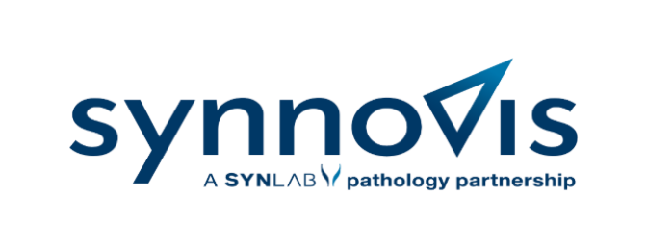


FAO GSG COURIERS

We are closed for training on ​​Click to select a date​​
From ​Click to enter time​ to ​​Click to enter time​​

We still require our scheduled collection. Once on site
please use the XX entrance to complete the collection OR please call this number ​click to enter number​ (Please delete and amend as appropriate) and a staff member will meet you

If you encounter any issues with the above, please contact us on ​click to enter number​

Many thanks in advance.
​​Click to enter name of the practice ​

Swiftqueue patient flowchart (Southwark & Lambeth)
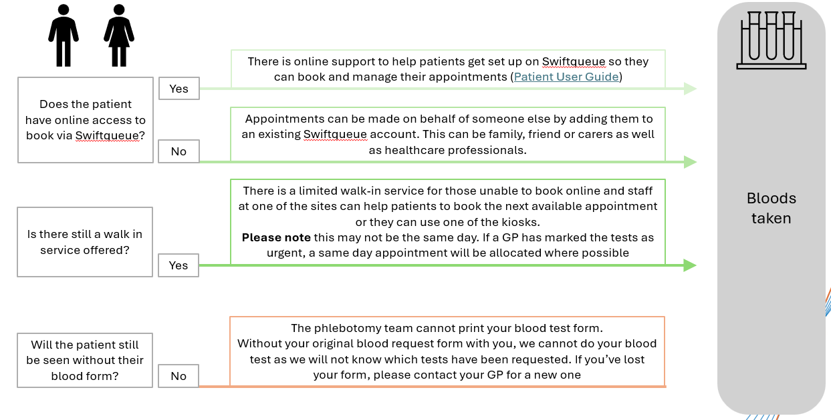

Phlebotomy hubs
Scan the QR code to book a Swiftqueue appointment
Gracefield Gardens Health Centre​
2-8 Gracefield Gardens, London SW16 2ST​

Tessa Jowell Health Centre​
72H East Dulwich Grove, London SE22 8EY​

Guy's Hospital​
Great Maze Pond, London SE1 9RT​

Kings Collage Hospital ​
Denmark Hill, London SE5 9RS​

St Thomas Hospital ​
Westminster Bridge Rd, London SE1 7EH​

Evelina Children’s Hospital​
Westminster Bridge Rd, London SE1 7EH​



A reminder of some basic phlebotomy dos and don’ts

  - Use closed blood collection systems only - transferring blood from syringes can lead to cell lysis and subsequent potassium leakage.
  - Are you taking blood samples in the correct order? Eg chemistry first to avoid contamination.
  - Release the tourniquet once the blood is flowing
  - Invert samples gently to mix with any additives in the tube e.g. purple EDTA, light blue citrate.
  - Ensure coagulation citrate tubes are filled up to the indicated line.
  - Pink tops for blood.
  - Transfusion tests MUST be handwritten, no pre-printed labels.

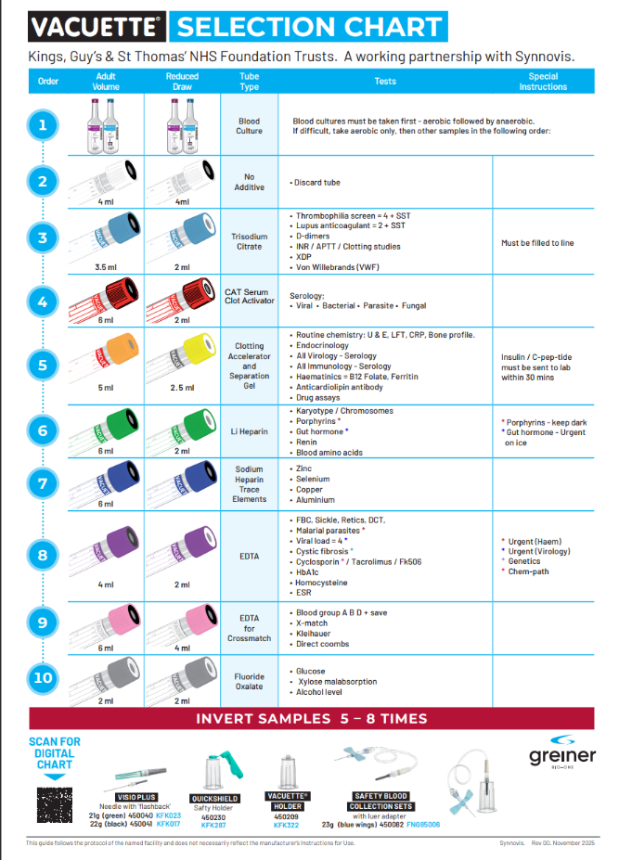

Primary Care Pathology Structure and Organisation
South East London

Introduction
The purpose of this document is to describe the organisational arrangements and relationships that underpin the provision of pathology testing services in South-East London.​
​
The slides explain 5 key elements:​
​
- Contractual and organisational relationships​
- Systems. roles and responsibilities​
- Structure of digital systems for ordering and resulting tests​
- Escalation procedures for issues raised by users​
- Process for requesting service changes​
​
The focus of this document is to explain the systems and arrangements for the benefit of GPs and primary care service users.​

Southeast London Pathology Services- Contractual relationships

Pathology services in southeast London are delivered by Synnovis on behalf of King’s College Hospital and Guy’s & St Thomas Hospitals NHS Foundation Trusts under contract to the South East London ICB.

GP Practices
Provide Personal Medical Services under a national contract with the NHS, managed locally by the ICB
Trusts
GSTT and KCH NHS Trusts hold the contract with the ICB to provide pathology services to Primary Care in South-East London. The Trusts sub-contract Synnovis to provide these services on their behalf
Synnovis
Partnership between Synlab LLP, KCH and GSTT.
Responsible for providing pathology testing services in South-East London via a network of laboratories including its ‘hub’ site at Blackfriars road
Pathology Business Unit
The PBU operates on behalf of the two Trusts to provide day to day oversight and management of the Pathology contract with Synnovis. It also manages requests for changes to services via Change Control Enquiries (CCE)
Integrated Care Board (ICB)
The ICB responsible for allocating NHS resource to deliver the local integrated care strategy.
The ICB contract with the GSTT and KCH trusts to provide pathology services in Southeast London
National GP Contract
Flow down Pathology Contract
Accountability
SE London Pathology Contract

Pathology systems infrastructure
Synnovis
Systems (tQuest & Keystone)
Synnovis manages the information stored, and provision of support for those using tQuest & Keystone.
Synnovis process the pathology requests received through tQuest and the sending back of results using the Keystone application.
GSTT Infrastructure (EPIC)
The Trust hosts the EPIC system of which Beaker (Synnovis’ laboratory management system) is a module.
GSTT holds a contract with Optum and is responsible for the hardware environment (servers that host the Optum Health application software and databases) on which the tQuest application is deployed.
Optum (formerly EMIS)
GP Systems
It is a supplier of GP Patient Management System, which include patient record systems and the tQuest ordering system to general practice via ‘Optum Web’.
Optum is also the proprietor of and responsible for the tQuest application via ‘Optum Health’.

Primary Care pathology test ordering infrastructure and process
2
Practice Management System
(Optum: electronic patient record, tQuest test ordering
Keystone
GSTT/SYNNOVIS/Optum Health
tQuest
GSTT/SYNNOVIS/Optum Health
Integration Engine
GSTT
Integration Engine
GSTT
Epic Beaker LIMS
Test Orders
GSTT/SYNNOVIS
Epic Beaker LIMS
Test Results
GSTT/SYNNOVIS
Ordering
Resulting

Primary Care tQuest escalation process

GP identifies an issue
Synnovis Helpdesk
Optum Health
GSTT-IT
Synnovis AMS Team
Is this an issue relevant to Optum software?
Investigation
Optum Web (GP systems)
e.g. Downtime, Failed orders, missing results, printer issues, results queries, etc.
New users, results interchange issues. results queries, etc?
If issue is identified immediately as relevant to Optum software
tQuest@synnovis.co.uk
ICB helpdesk
Hardware issue or requires IT facilitator support

Change control enquiries
Requests for additions or changes to pathology services, e.g. tQuest, the test catalogue, sample collection routes etc, must be made using the Change Control Enquiry Form (This can be obtained from Request changes to pathology services | Synnovis).
Completed applications will require support from both the ICB and the hospital Trusts (via the Pathology Business Unit-PBU), before it is forwarded to Synnovis to confirm if the request is both possible and practicable. Synnovis then reviews the request and submits a response to the PBU that then considers application and respond to the ICB on whether the contractual change is feasible and can be supported.

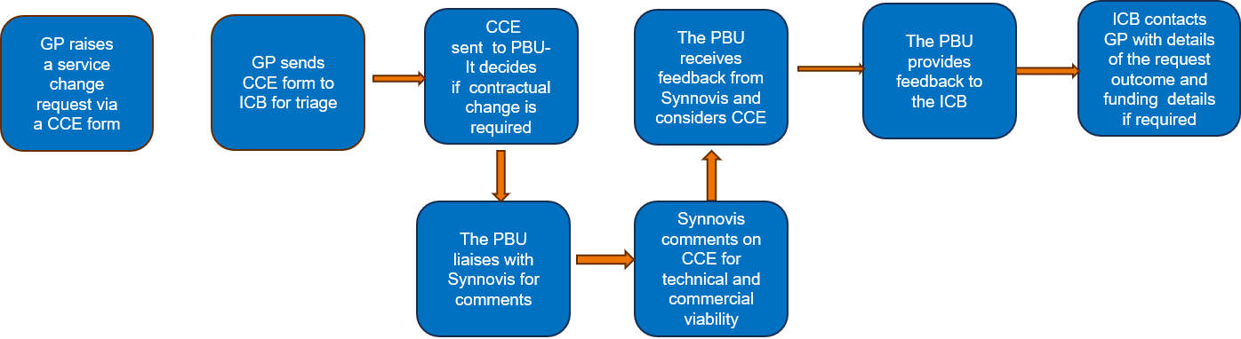
The CCE form must be complete and emailed to: joanne.lawlor@selondonics.nhs.uk and cheryl.leung@selondonics.nhs.uk

MICROBIOLOGY URINES – Two options for Boric Acid tubes (not suitable for Chemistry Urine Testing)
Becton Dickinson collection cup and green top tube combo  Both available in packs of 100 - Should be ordered together  Available via Synnovis and Trusts |  |  |  |  | Brand: Sarstedt Monovette  Product Code: 10.253.001  Bag of 64  NHS Supply chain code: KTH123  Also suitable for catheter and paediatric collection bag samples  Available via Synnovis and Trusts
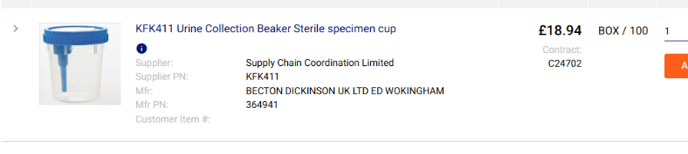 | NHS Supply chain code: KFK411 | 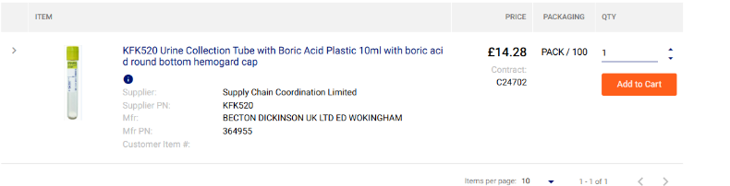 | NHS Supply chain code: KFK520
MICROBIOLOGY SWABS
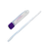 | Purple Cap Liquid Swab - Regular Foam/Flocked Tip  for all microbiology culture single swab tests,  e.g. wounds, nasal, genital and throat etc  The exception is N. gonorrhea culture (see below) |  |  |  | Brand: Medical Wire  Product Code: MW176S  Box of 125  NHS Supply chain code: HHD260  Available via Synnovis and Trusts
 | Black cap Gel Amies Charcoal swab - Rayon tip  Only for sexual health screening, if GC culture and sensitivity/susceptibility is required  Or for newborn eye testing, if Neisseria gonorrhoeae |  |  |  | Brand: Medical Wire  Product Code: MW171  Box of 125  NHS Supply chain code: HHD024  Available via Synnovis and Trusts
Aptima for chlamydia or gonorrhoea NAAT (more sensitive than culture)  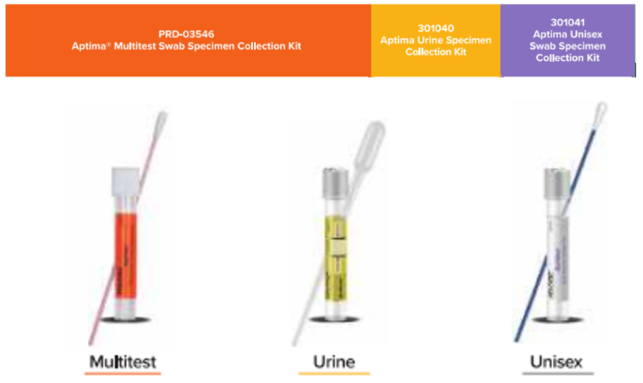  Supplier: Hologic Ltd Boxes of 50 - All Available via Synnovis and Trusts |  |  |  |  | CT/NG, Trichomonas Vaginalis, Mycoplasma genitalium  Multitest - vaginal, rectal, throat, penile meatal, and lesion swabs for above tests plus vaginosis, vaginitis, HSV1 & 2  NHS Supply chain code: HHD186  Unisex - female endocervical or male urethral swab specimens for above tests  NHS Supply chain code: HHD187  Urine – for above tests  NHS Supply chain code: HHD185
VIROLOGY SWABS
 | Red Cap Universal Transport Media Swab – Flocked Tip  For any viral swab specimen, eg respiratory, HSV, genital or skin.  Suitable for viruses, mycoplasma and ureaplasma only  Not suitable for bacterial culture |  |  |  | Brand: Copan  Product Code: 360C  Box of 50  NHS Supply chain code: KCP85113 Supplier: Sterilab
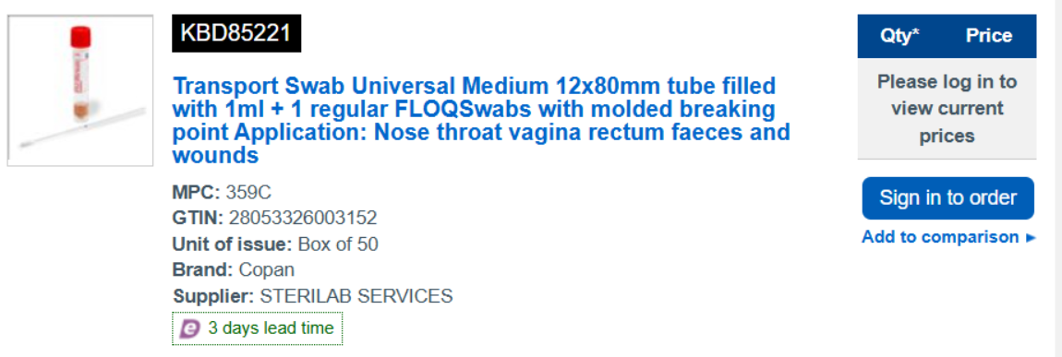 | Red Cap Universal Transport Media Swab - Flocked Tip  Any viral swab specimen requiring a flexible/narrow shaft  eg paeds, nose, urethra, throat, rectum etc  Suitability as above |  |  |  | Brand: Copan  Product Code: 359C  Box of 50  NHS Supply chain code: KBD85221 Supplier: Sterilab
The above RED swabs are the preferred Virology options, but we will also accept the GREEN ones below:
 | Green Cap Liquid Virus Swab - Foam Tip  For any viral swab specimen,  eg respiratory, HSV, genital or skin etc  Not suitable for bacterial culture |  |  |  | Brand: Medical Wire  Product Code: MW951S  Box of 125  NHS Supply chain code: HHD225  Available via NHSSC & GSTT Trust
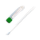 | Green Cap Liquid Virus Swab – Foam Tip  Any viral swab specimen, requiring a flexible/narrow shaft  eg Paeds, urethra, nose, throat, rectum  Not suitable for bacterial culture |  |  |  | Brand: Medical Wire  Product Code: MW951SENT  Box of 125  NHS Supply chain code: HHD749  Available via NHSSC & GSTT Trust

